

DANIEL FRANCO
FUNDAMENTOS DE PROGRAMACION
AVANCE DEL RETO/PROYECTO

INDICE
LUNES
Estado de mi celular
Crea tu cuenta
Wi-Fi del café
Mis estadísticas de creador
Tienda de accesorios
Meta de ahorro
Control de tiempo de pantalla
Cuenta entre amigxs
MARTES
Tamaño de tu bebida
Nivel de influencer
¿Qué me pongo hoy?
Playlist según tu mood
Mensaje según tu calificación
Costo de envío
Rango en tu videojuego
Reto: arma tu bubble tea

LUNES/MARTES

EJERCICIO 1
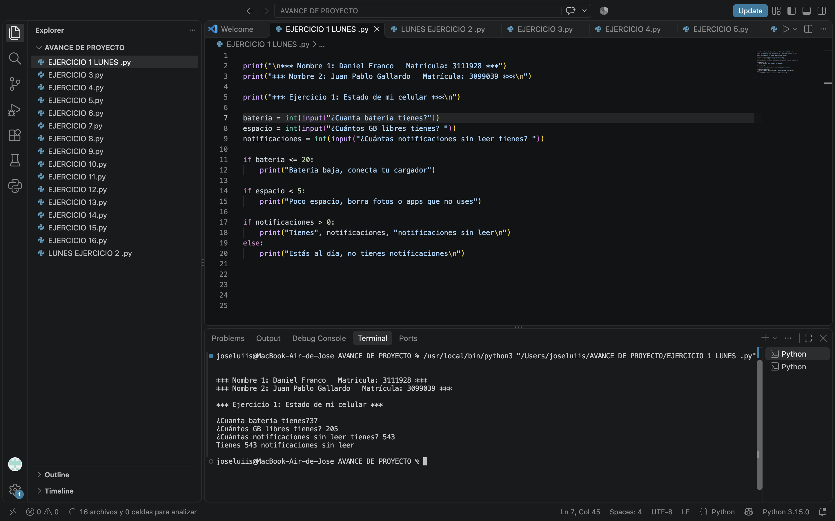
https://lucid.app/lucidchart/558dbb42-9f3d-49f5-903e-5462a12ec6b9/edit?page=page1&invitationId=inv_7258ce62-43bd-44b0-809b-9ab96fe958cf#

EJERCICIO 2
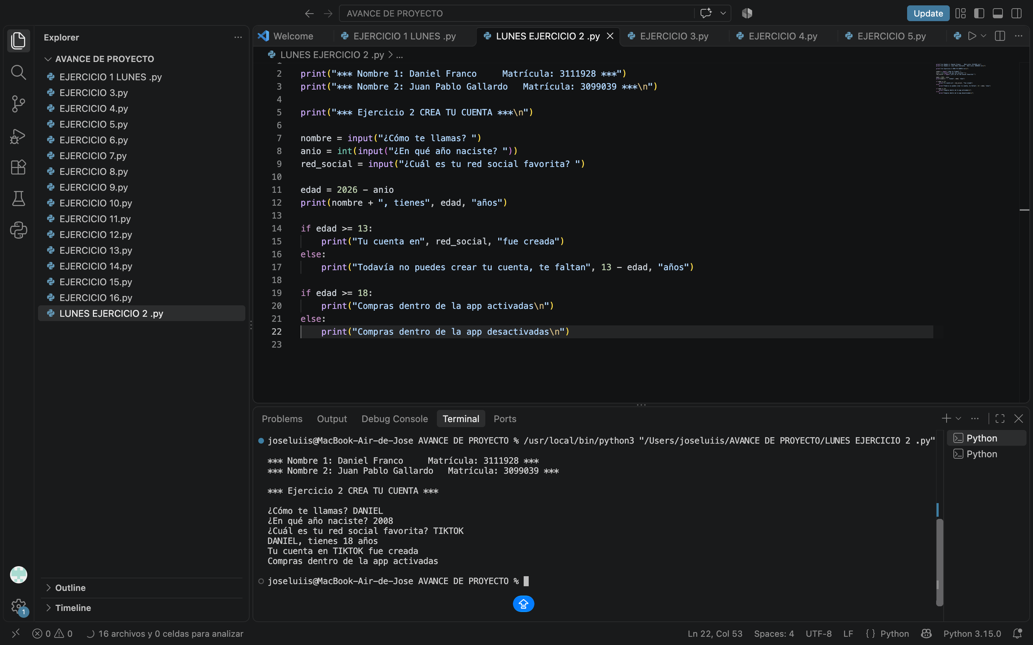
https://lucid.app/lucidchart/429a4709-e09c-4ce5-bd80-f04828c1bf06/edit?page=page1&invitationId=inv_a1c91545-b749-4342-bfd9-0b652628f2e3#
EJERCICIO 3
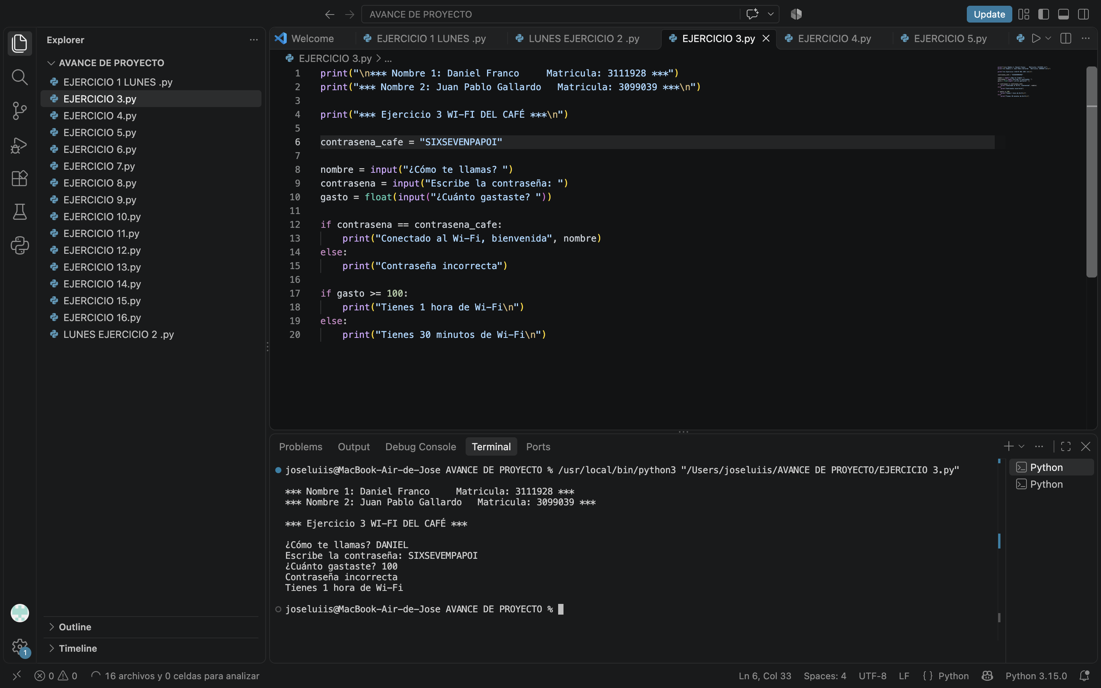
https://lucid.app/lucidchart/fbf33bd1-4918-4098-acb3-27f1a9caf0e9/edit?viewport_loc=38%2C-224%2C2330%2C1184%2Cpage1&invitationId=inv_98f9131e-00fa-47f5-a29a-ef11bc80d935

EJERCICIO 4
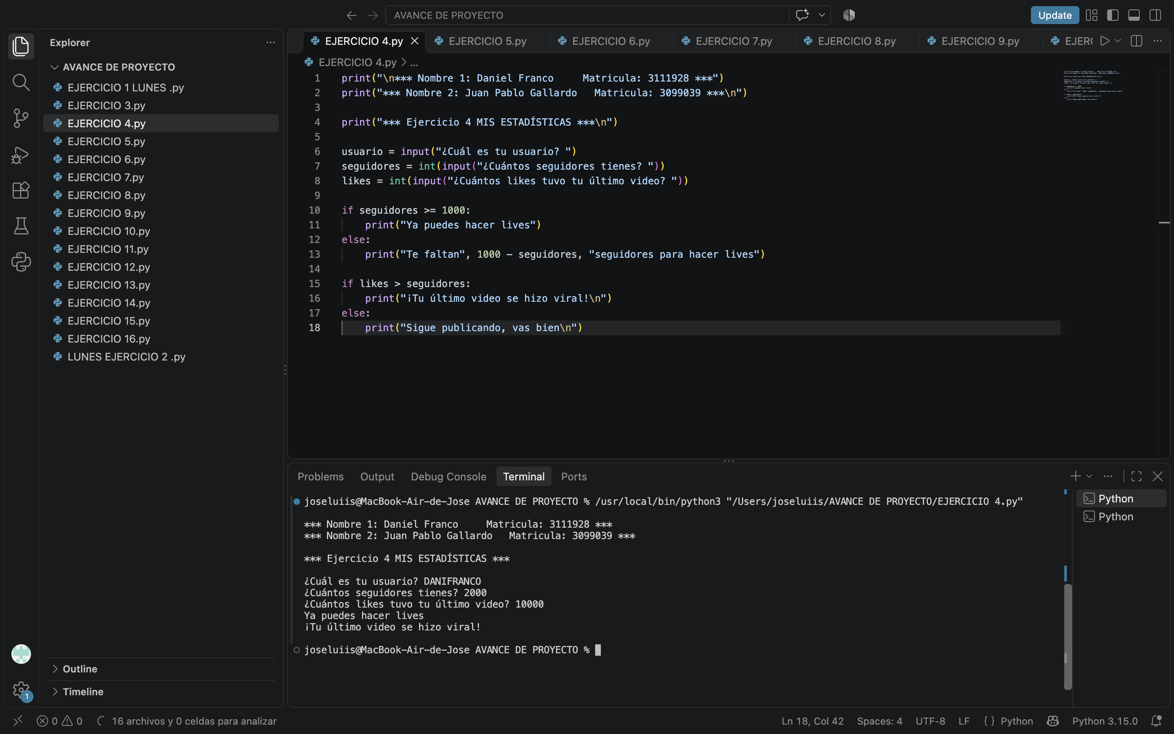
https://lucid.app/lucidchart/51e18c28-15ed-445a-af42-6955b464b731/edit?viewport_loc=21%2C-430%2C2200%2C1118%2Cpage1&invitationId=inv_59f40665-4a37-46ee-8728-41b13a9ba771

EJERCICIO 5
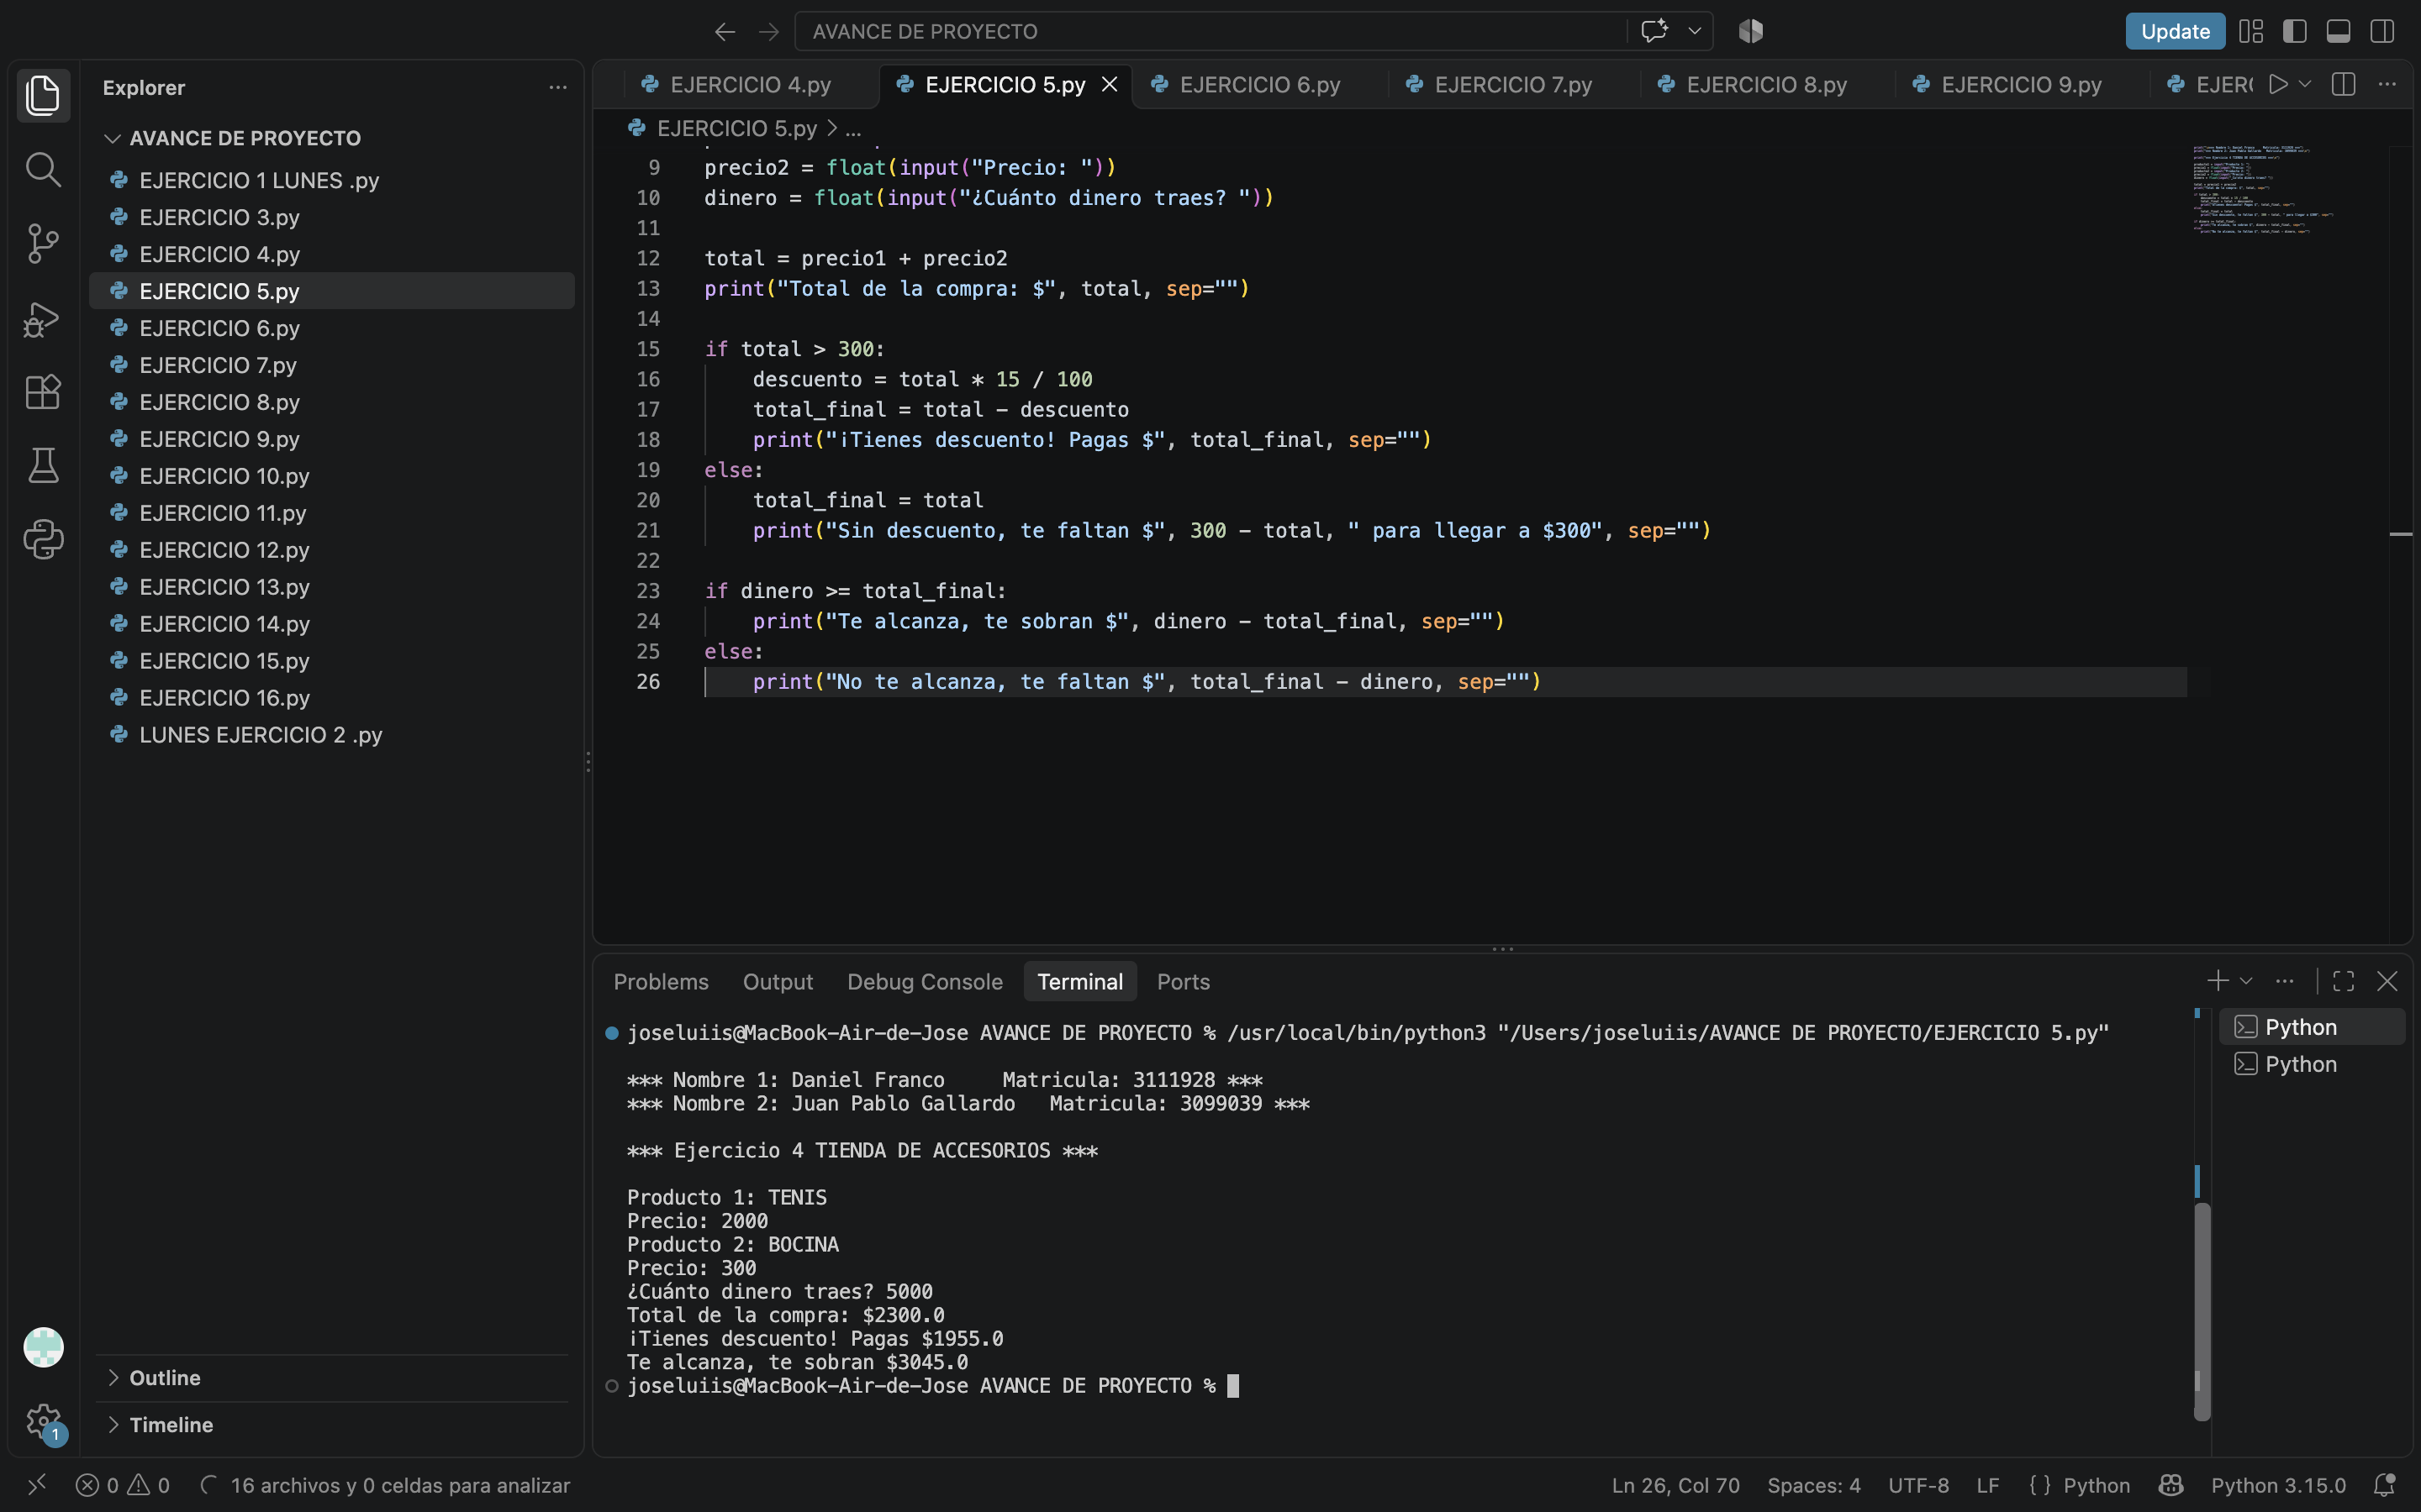
https://lucid.app/lucidchart/3b7e0ebd-af6c-4477-beff-69e5e7bc96f2/edit?viewport_loc=40%2C-304%2C2430%2C1235%2Cpage1&invitationId=inv_58d604be-52e8-43cd-98ef-a5e195e18f62

EJERCICIO 6
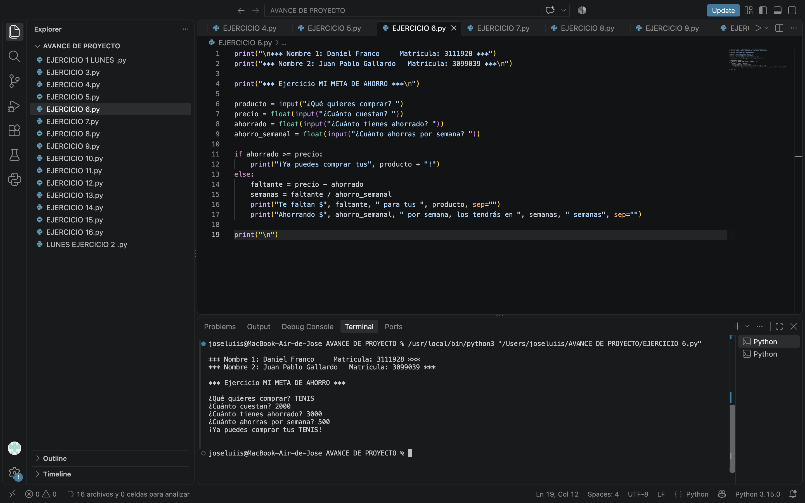
https://lucid.app/lucidchart/5da63c54-b6e2-4bb1-b980-aaed43651d87/edit?viewport_loc=79%2C-207%2C2140%2C1088%2Cpage1&invitationId=inv_04bb5b11-d17d-4c27-ab65-b88715218da7

EJERCICIO 7

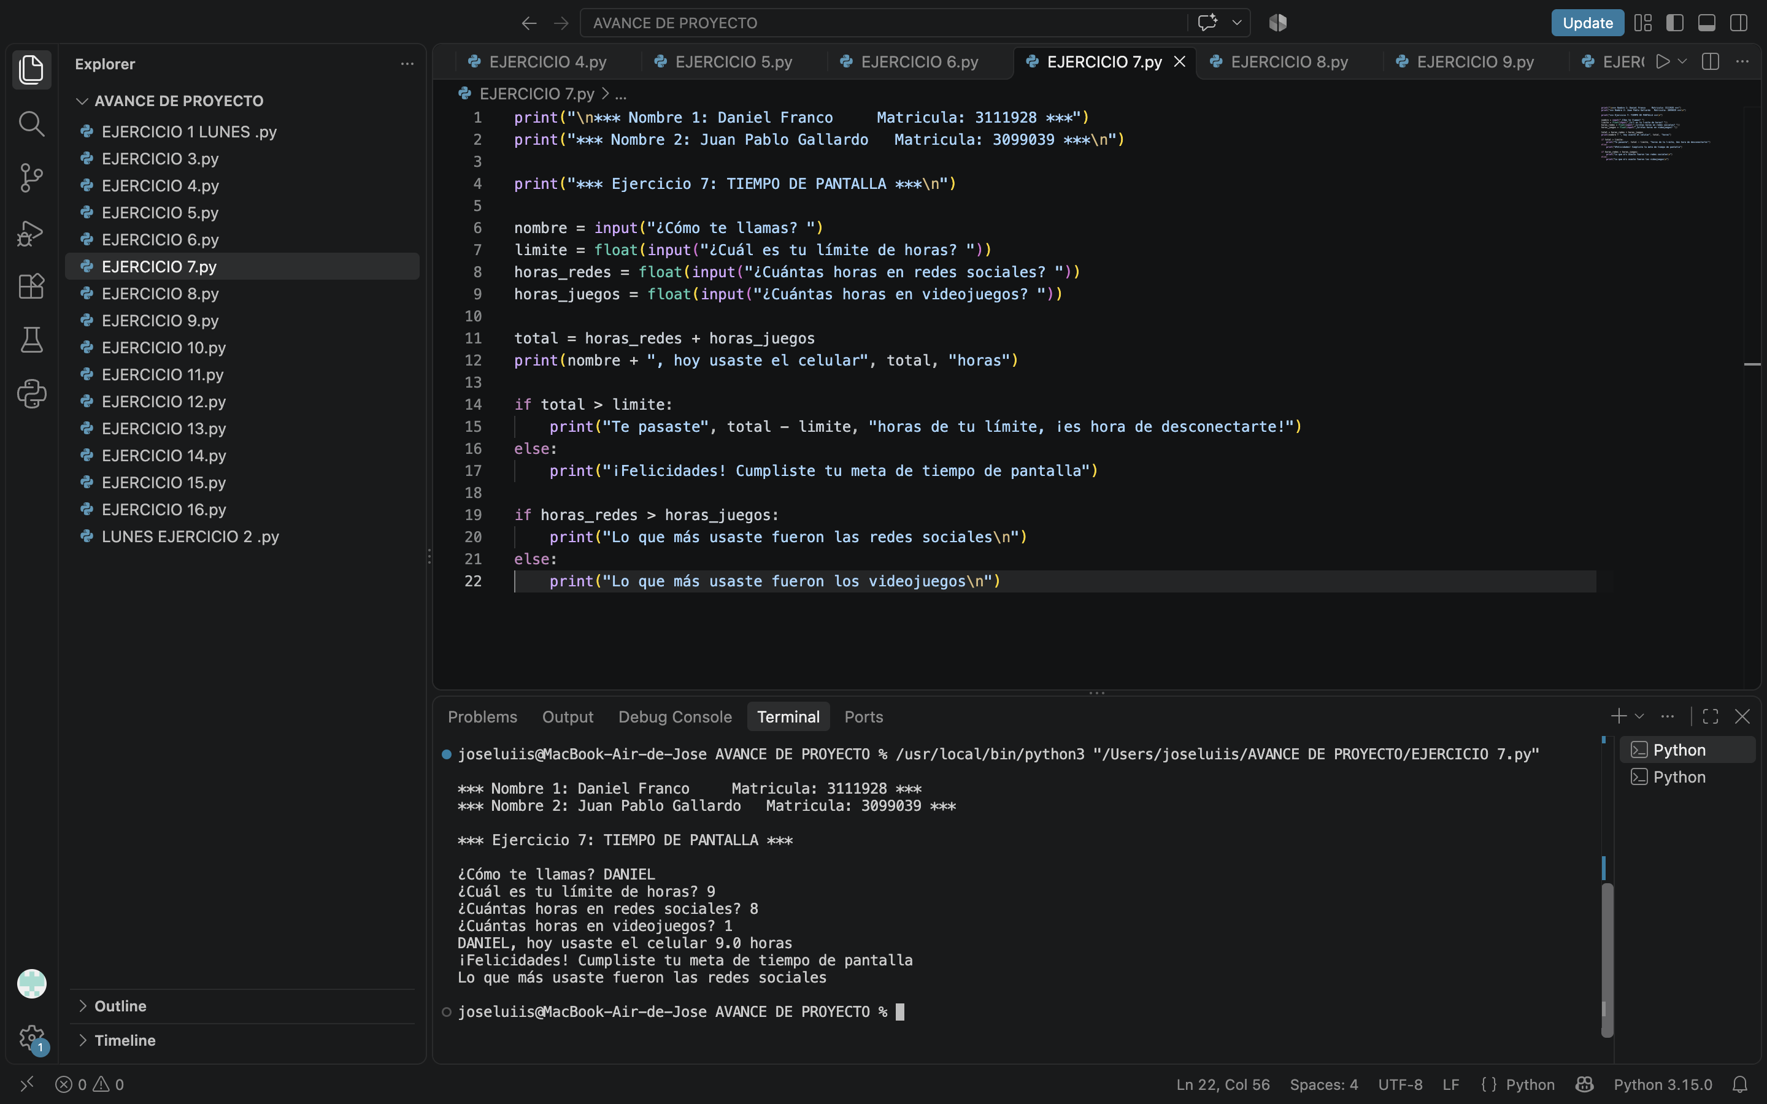
https://lucid.app/lucidchart/2f1b9041-17de-4d7c-a69f-d210badf7680/edit?viewport_loc=60%2C-492%2C3310%2C1683%2Cpage1&invitationId=inv_e9b5452b-9e78-4670-825f-38da3e96c38b

EJERCICIO 8
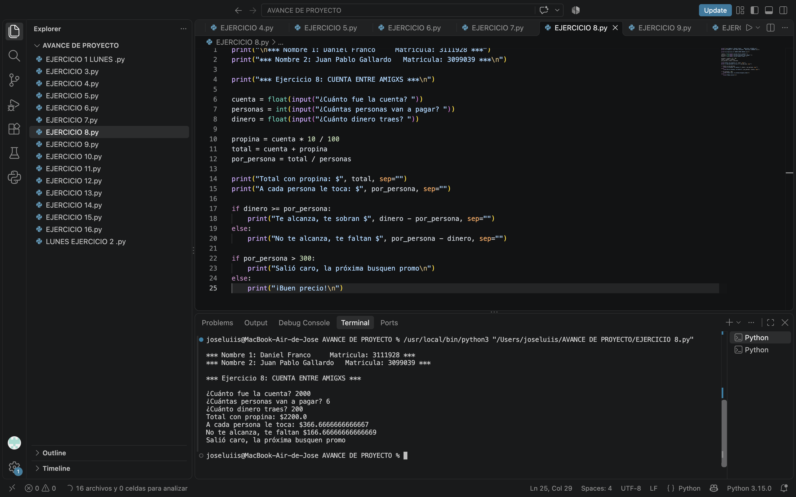
https://lucid.app/lucidchart/364fd697-f8cb-4d56-b5c1-cf3e7f04c44d/edit?viewport_loc=-51%2C-277%2C2210%2C1123%2Cpage1&invitationId=inv_34eec509-996d-48d7-ba3c-929d928a5c55

EJERCICIO 9
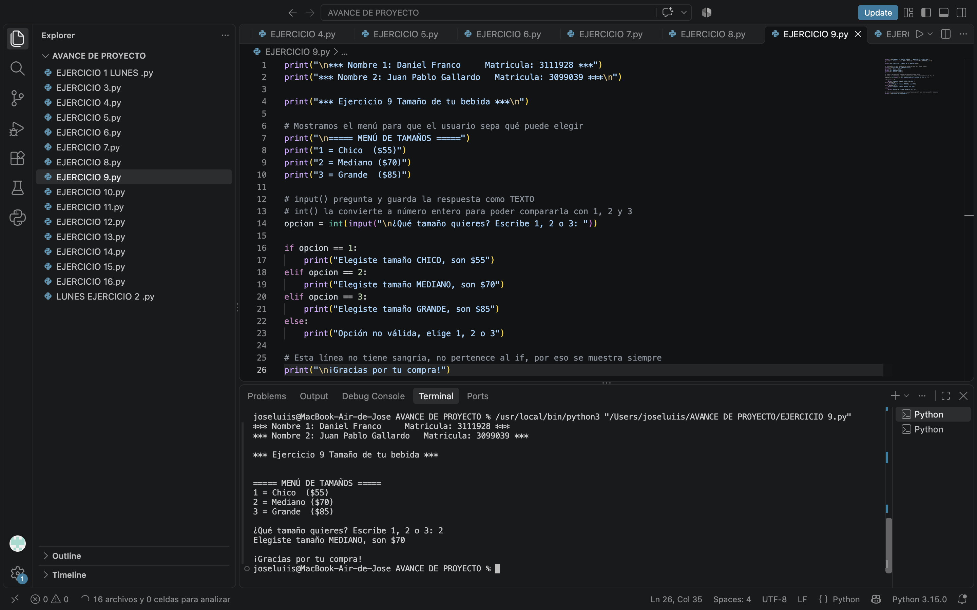
https://lucid.app/lucidchart/5466cab7-eb02-471e-93a1-6ceed4c42eec/edit?viewport_loc=299%2C-223%2C2230%2C1134%2Cpage1&invitationId=inv_34e25660-0f85-447d-a9da-6bd957e45705

EJERCICIO 10
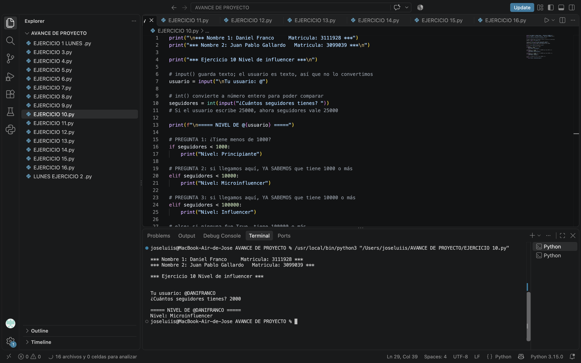
https://lucid.app/lucidchart/225fd134-7127-4301-861d-fe15d5d992d2/edit?viewport_loc=41%2C-223%2C2250%2C1144%2Cpage1&invitationId=inv_a924237d-63e2-443f-97b2-f4f8ba944b64

EJERCICIO 11
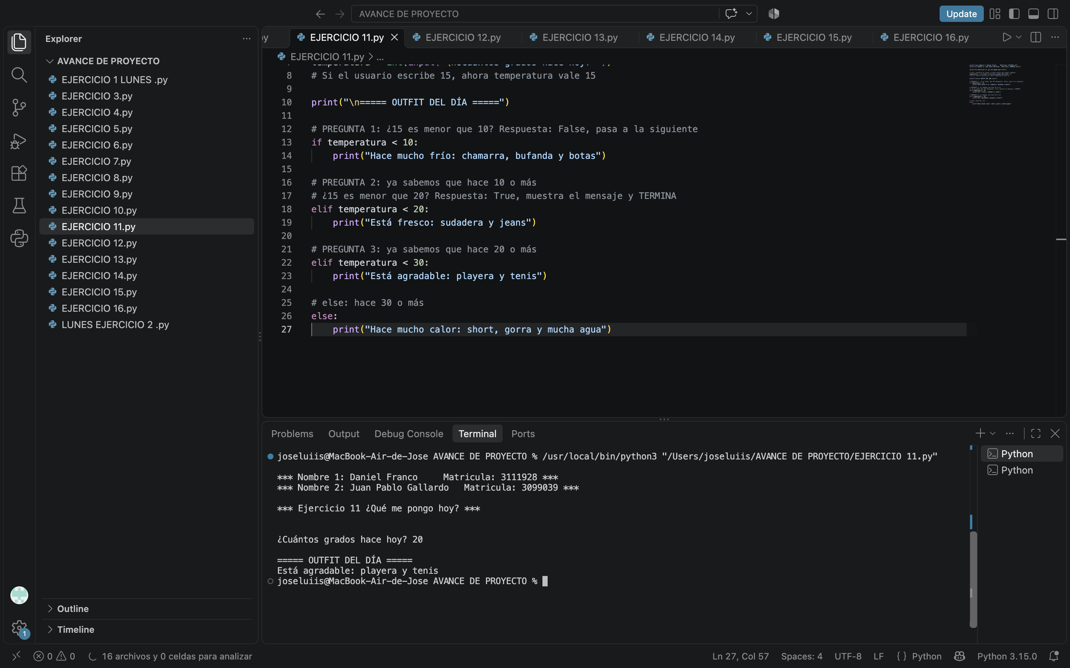
https://lucid.app/lucidchart/6acfd8ba-b9a3-4f9f-b9d4-bc3ca7ee5514/edit?viewport_loc=40%2C-277%2C1900%2C966%2Cpage1&invitationId=inv_20c81bdb-cf0d-474f-b986-4f6d557808f3

EJERCICIO 12

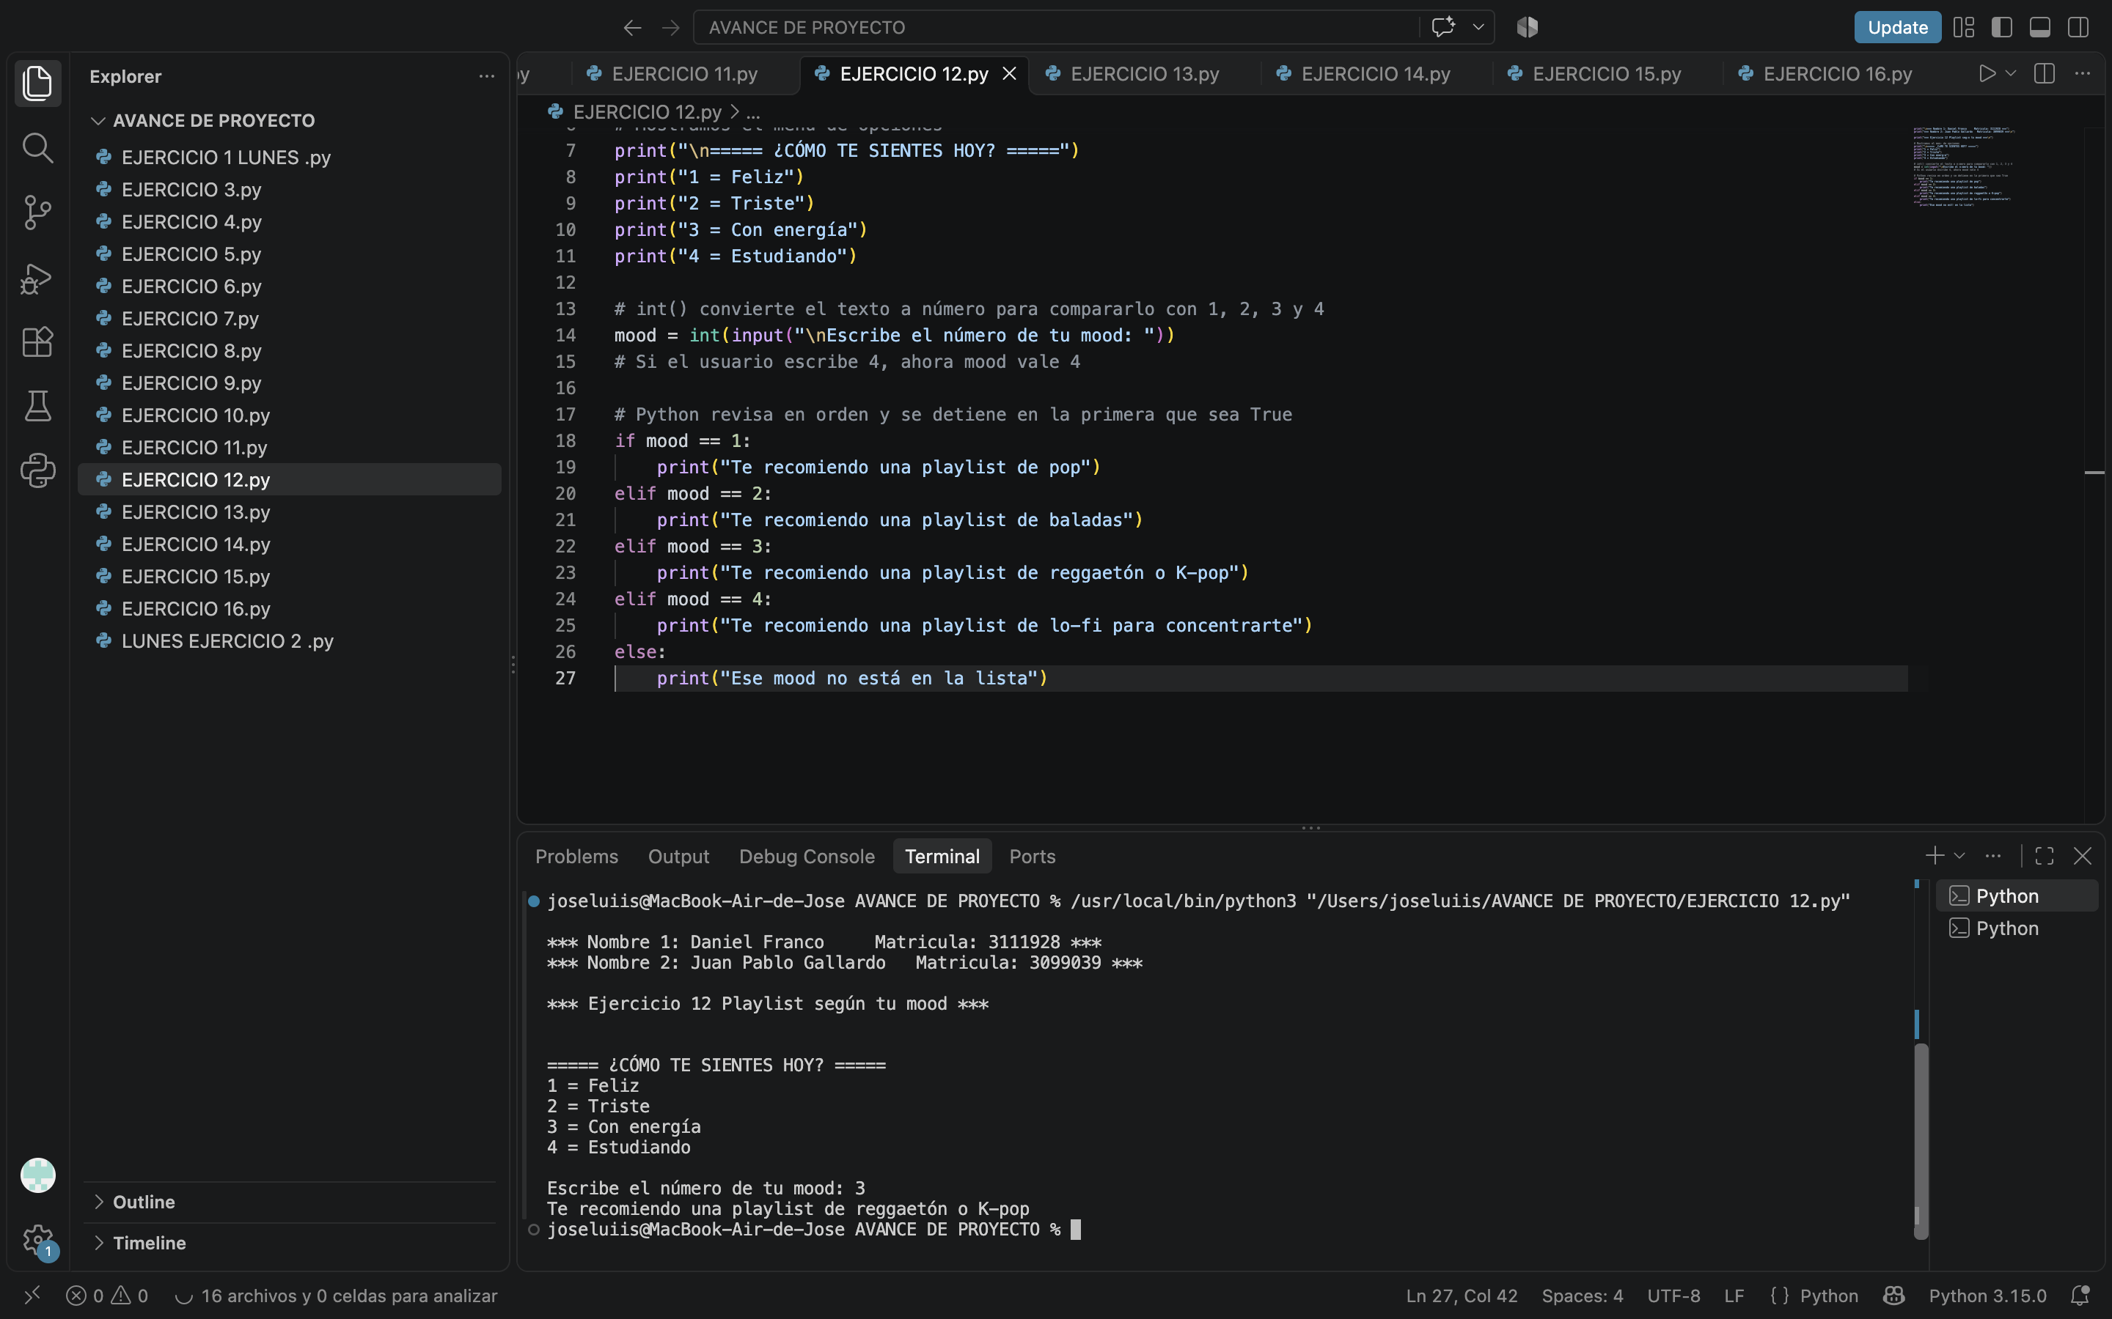
https://lucid.app/lucidchart/6771dde2-df63-4f31-9d20-6b9a71bc0097/edit?viewport_loc=40%2C-344%2C2180%2C1108%2Cpage1&invitationId=inv_863251f1-d806-4b40-ba86-113416a21892

EJERCICIO 13

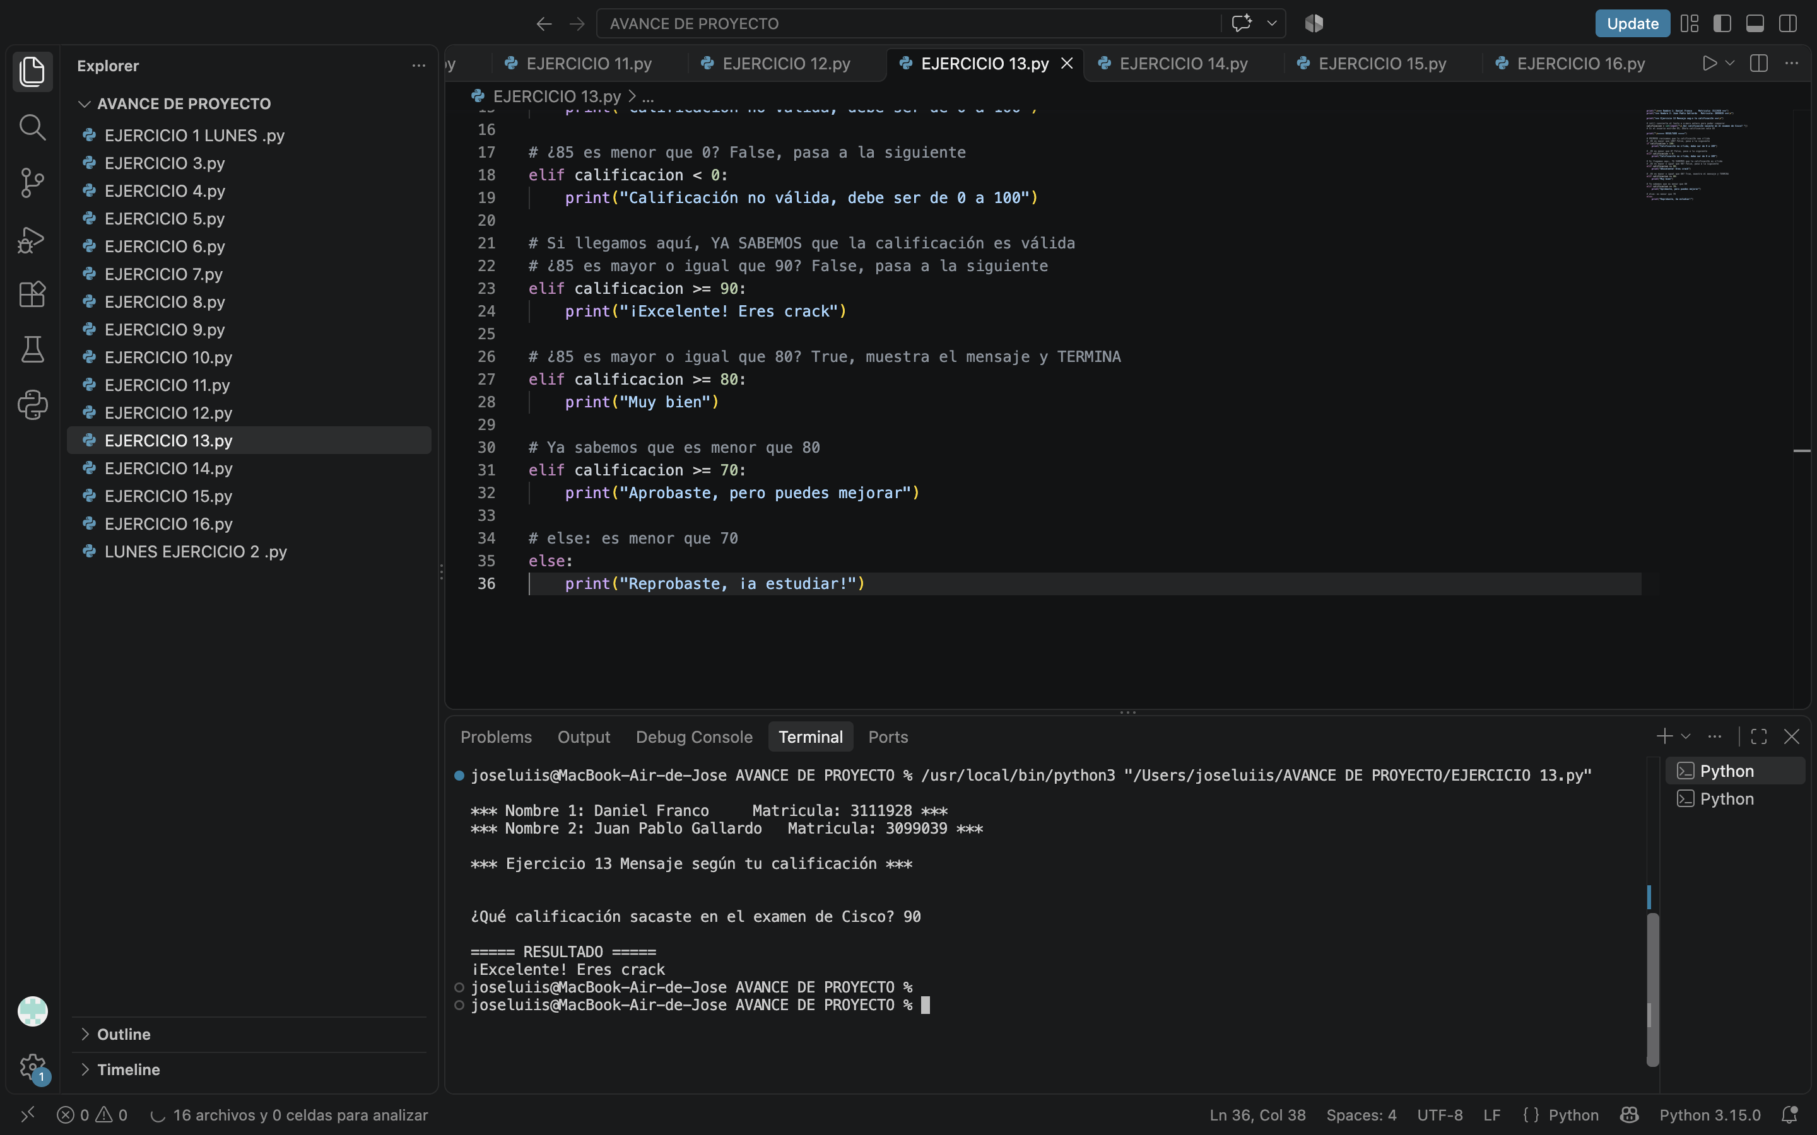
https://lucid.app/lucidchart/6bf5b808-32b5-47c1-92cf-5bf81fa1936a/edit?viewport_loc=40%2C-392%2C2380%2C1210%2Cpage1&invitationId=inv_abb2b725-8e97-436c-80b6-8fccf5f8c4f4

EJERCICIO 14

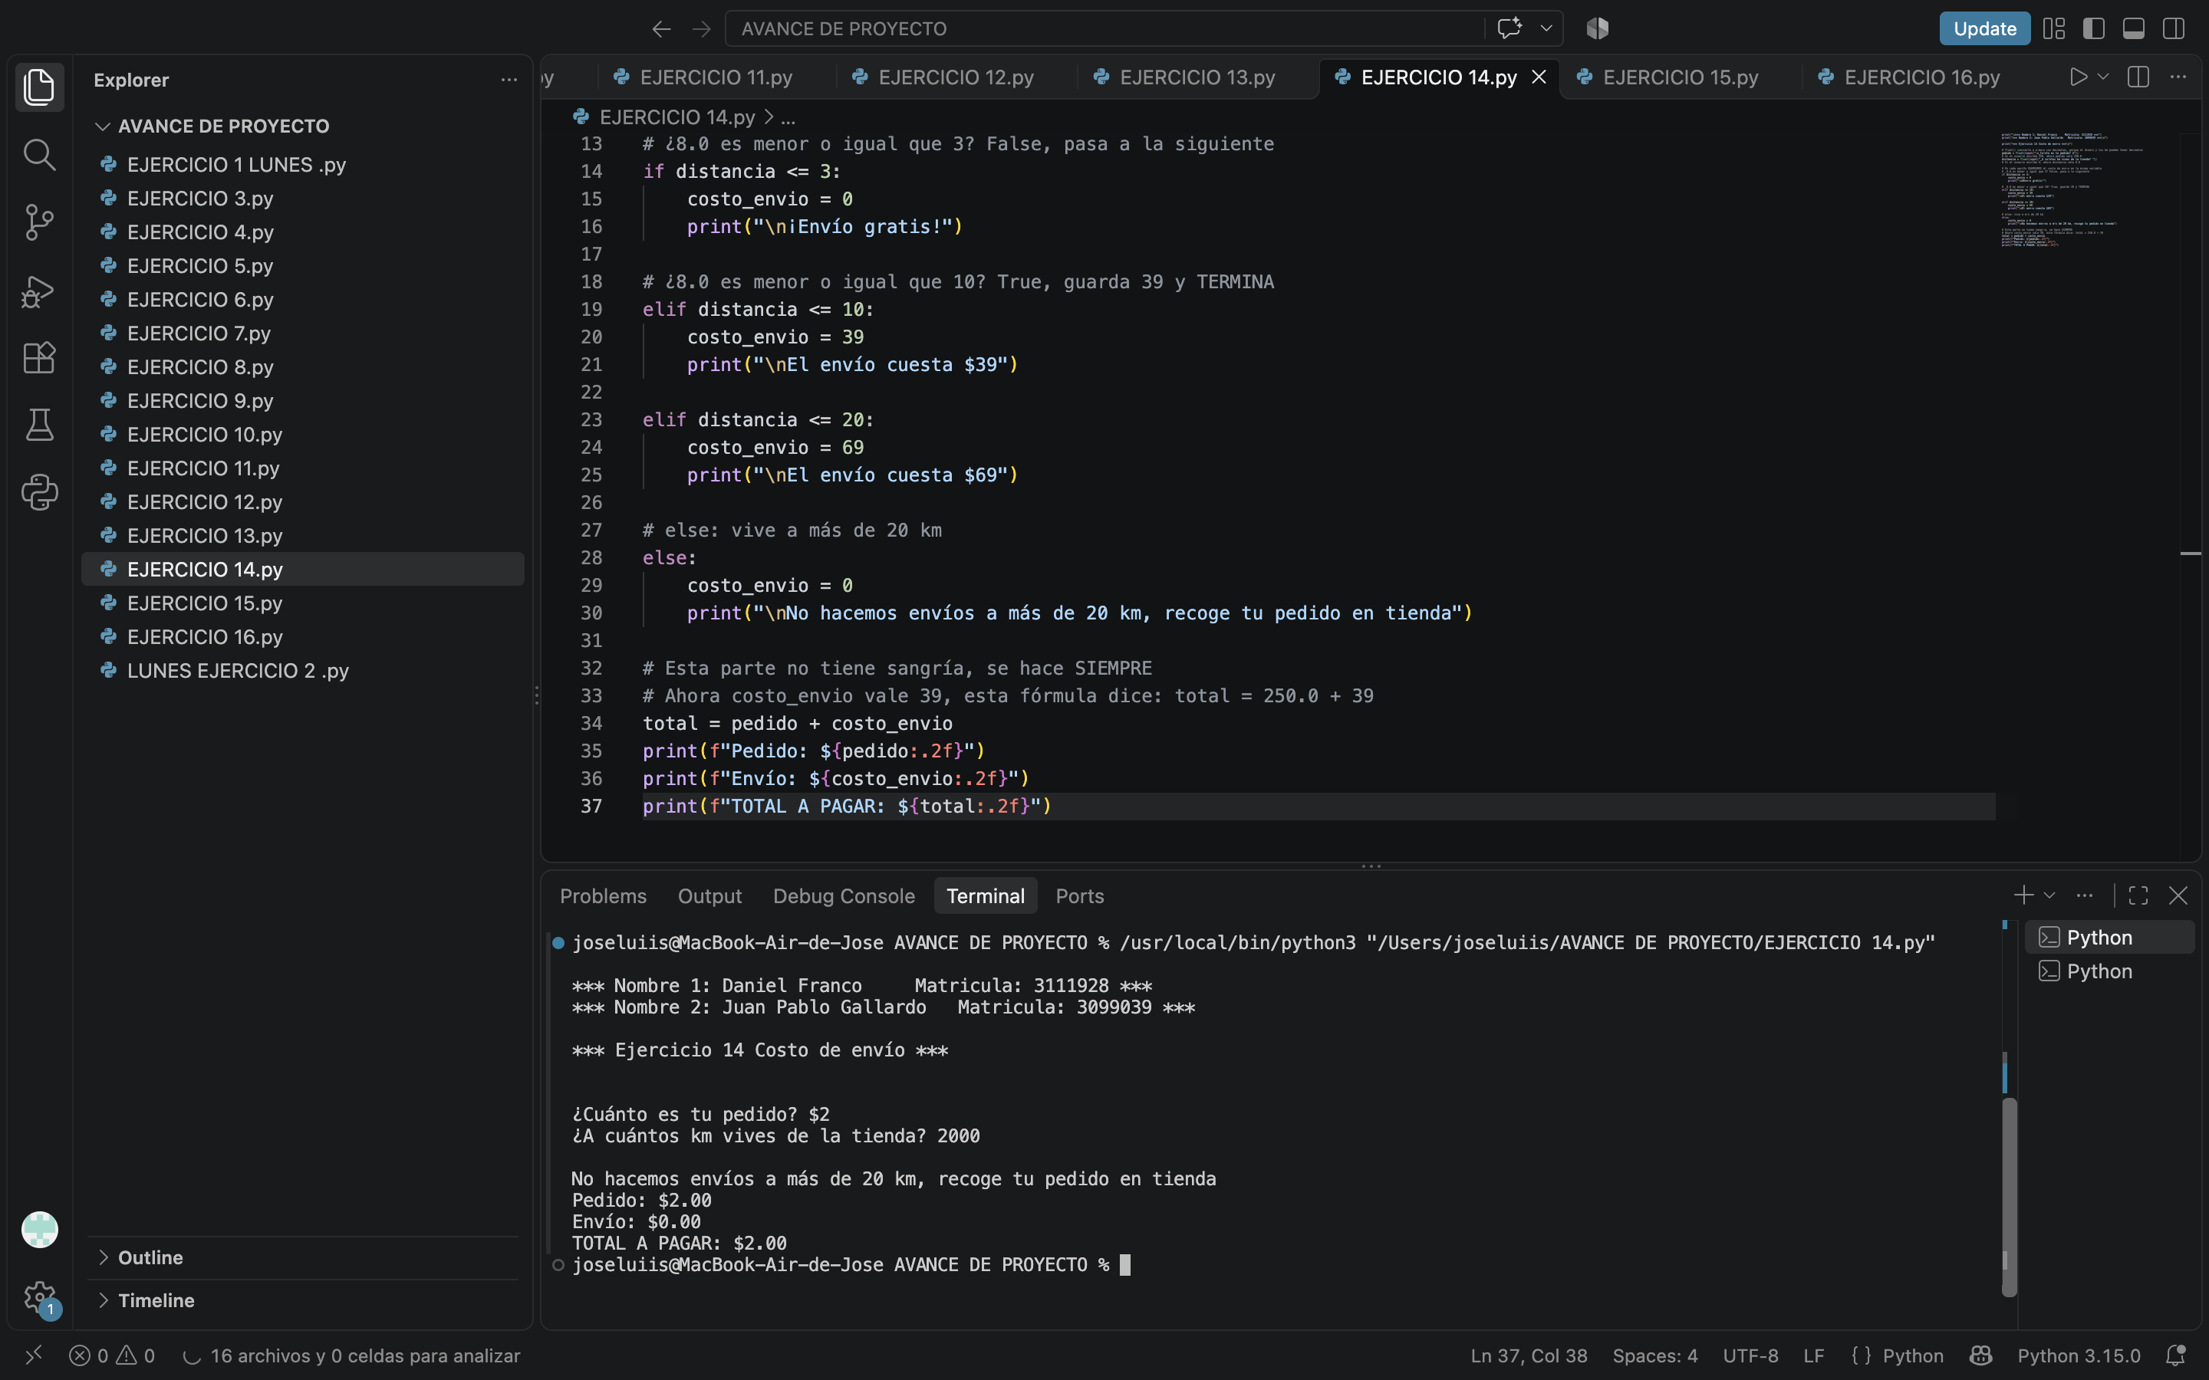
https://lucid.app/lucidchart/7a0bc109-84a2-4621-8c40-20af8b599eb1/edit?viewport_loc=40%2C-359%2C2330%2C1184%2Cpage1&invitationId=inv_1ecb6593-34c1-4bff-9002-f3ad4e64b4e6

EJERCICIO 15
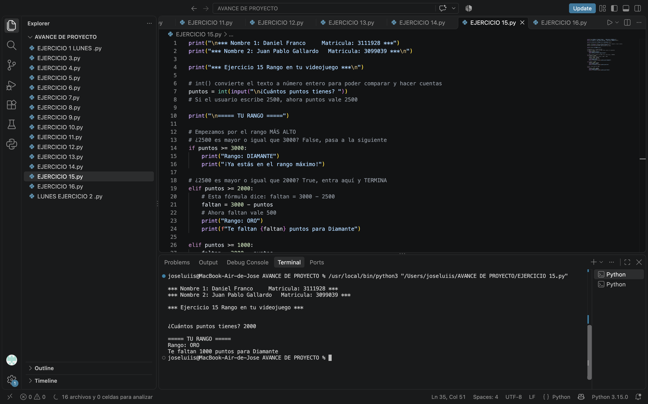
https://lucid.app/lucidchart/149f0e1f-5d01-486e-87e3-cb5feac808a8/edit?viewport_loc=40%2C-279%2C2030%2C1032%2Cpage1&invitationId=inv_5f6f1067-0fa8-4bb6-9d33-6a5fc8e38223

EJERCICIO 16
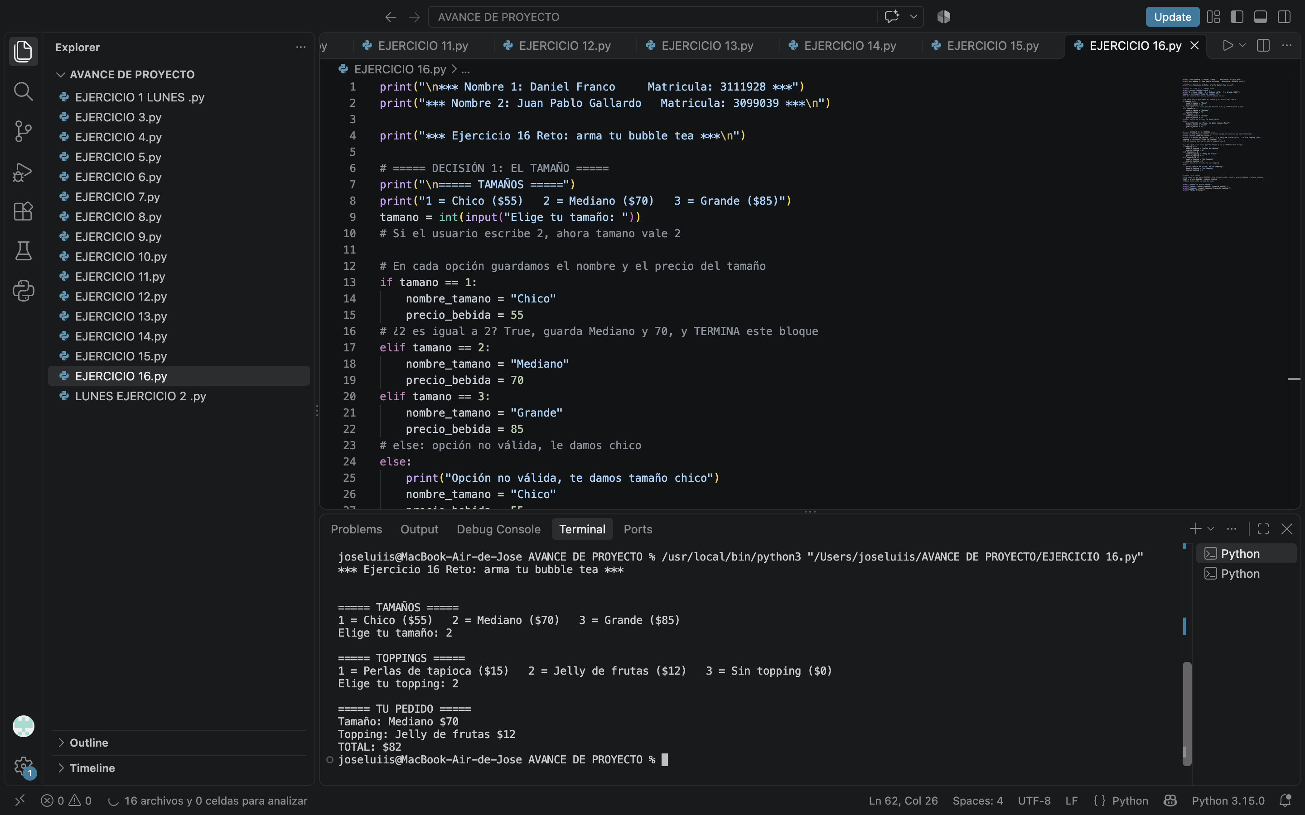

https://lucid.app/lucidchart/2151750b-5e72-41f8-878e-8d028c180e0c/edit?viewport_loc=41%2C-778%2C4190%2C2130%2Cpage1&invitationId=inv_923cc666-8fa5-4230-bb35-eaf7b9b5c447

EJERCICIOS/DIAGRAMSS MIERCOLES

1-https://lucid.app/lucidchart/b04ab561-b3e5-4c25-a8a3-f1ce2a06b88e/edit?viewport_loc=31%2C-325%2C2560%2C1301%2Cpage1&invitationId=inv_4f88b960-48a9-4c26-a222-2ac96d0f87ea

2- https://lucid.app/lucidchart/02b94e1a-4df9-4b80-93a9-4ed3c7ae85b6/edit?viewport_loc=0%2C-172%2C2030%2C1032%2Cpage1&invitationId=inv_b2a97992-d9c9-49e4-abad-2a318af26fcf
3- https://lucid.app/lucidchart/80ed0967-cd96-414b-b845-f7f7cc19d0b4/edit?viewport_loc=23%2C-202%2C2390%2C1215%2Cpage1&invitationId=inv_a325d70e-eee4-479f-8c85-85e15791c8a2

4- https://lucid.app/lucidchart/80ed0967-cd96-414b-b845-f7f7cc19d0b4/edit?viewport_loc=23%2C-202%2C2390%2C1215%2Cpage1&invitationId=inv_a325d70e-eee4-479f-8c85-85e15791c8a2

5- https://lucid.app/lucidchart/660a69e5-28a3-46b2-85b3-891172e6a45d/edit?viewport_loc=10%2C-150%2C1860%2C946%2Cpage1&invitationId=inv_cd374a03-caf7-4a35-ab27-32f42a415e23

6- https://lucid.app/lucidchart/335c3415-615d-4b94-a4ce-cb85cde1eec4/edit?viewport_loc=-571%2C-512%2C2719%2C1382%2Cpage1&invitationId=inv_3c78f0a6-1719-4393-a00a-b993c2450e73

